

**Group Report – Agile Business Analysis**

# Mortgage transparency for every stakeholder’s happiness

Authors: Anuradha Kishore - Agnes Pakozdi - Tran Ngoc Anh - Gaël Feyertag

Coach: Prof. Dr. Knut Hinkelmann

Inhalt

Mortgage transparency for every stakeholder’s happiness 1

Introduction & Problem Statement 2

One Page – Background information 2

Elicitation and Collaboration 3

Which stakeholders were involved and why? 3

How did we obtain information from stakeholders? 3

How did you communicate with stakeholders? 3

Which techniques were applied and what are the experiences? 3

requirements lifecycle management 4

Strategy Analysis 5

Requirements Analysis and Design Definition 6

Solution evaluation 7

conclusion 8

## Introduction & Problem Statement

In the application of its module **Business Agile Analysis** (ABA), the Group 9 (AAAG) chose to imagine a scenario where **Money Park**, a leading provider in the brokerage of Mortgage in Switzerland, launches a new project.

Hereafter, Money Park charges a small project team (Group 9) to conduct a **preliminary project work** in an **agile way** on **the complex mortgage ecosystem** to make this business area and topic **easier**, **better understandable** and **more transparent** to increase all stakeholders' happiness.

In this report, the group 9 is dedicated to report the tasks it performed within the described (fictive) project during the three sprints along the Business Analysis Knowledge Areas: **Elicitation and Collaboration**, **Requirements Lifecycle Management**, **Strategy Analysis**, **Requirements Analysis and Design Definition** and **Eventually Solution Evaluation.**

## One Page – Background information

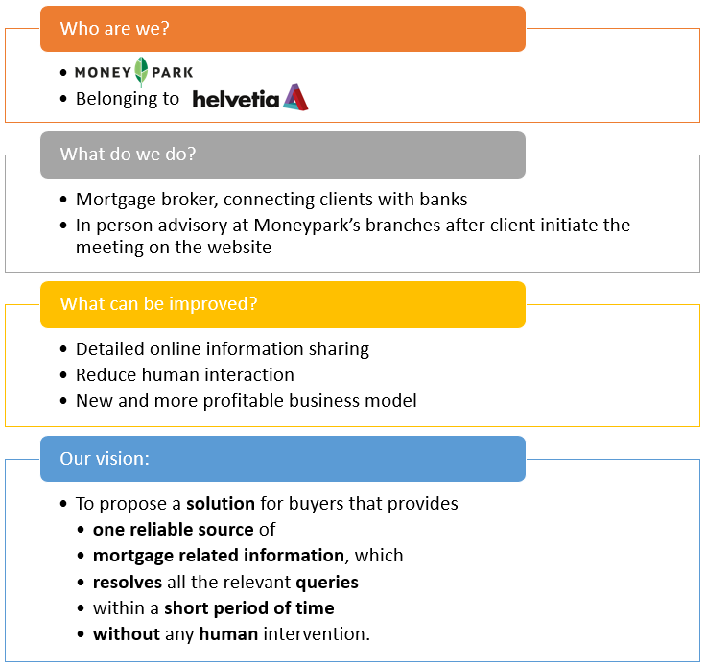

## Elicitation and Collaboration

According to the BABOK guide, the Elicitation and Collaboration area describes the tasks that business analysts perform to obtain information from stakeholders and confirm the results. It also describes the communication with stakeholders once the business analysis information is assembled. Elicitation is the drawing forth or receiving of information from stakeholders or other sources. Collaboration is the act of two or more people working together towards a common goal. The Elicitation and Collaboration knowledge area describes how business analysts identify and reach agreement on the mutual understanding of all types of business analysis information.

### Prepare Elicitation

The purpose of Prepare for Elicitation is to understand the scope of the elicitation activity, select appropriate techniques, and plan for (or procure) appropriate supporting materials and resources.

In our project, the first task in this phase was to define our stakeholders, as defined in our vision. Therefore, we built up a stakeholder analysis. The document can be retrieved in the github of the project. Two other elicitation tasks consisted on searching to define transparency and happiness based on desk research as well as information on the mortgage market and the as-is situation. Following those tasks, we were able to map stakeholders to our happiness findings and agree on limiting the primary scope of the project to customers and potential customers. We decided to limit the project scope to the customers as the aim of this project was recognized to show controversial results if transparency had to be analyzed from the different market players (supply side) or customers (demand side).

The conducted desk-research enabled us to formulate hypothesis on the customer's pain points leading to the current dissatisfaction in term of mortgage transparency. To explore and validate the pain points to work on in this project, we designed a persona to depict our typical customer. We tried to validate or explore further Pain Points through the elaboration of a questionnaire that we submitted through personal interviews with interviewees chosen based on our persona. After Analysis, we worked on several prototypes to conduct a second interview round with further interviewees with similar characteristics. Both Questionnaires and Persona can be retrieved in the project's github space. We eventually closed after the second interview analysis (in sprint three) by proposing to the management a detailed project query with project scope and a prototype to align with our above-mentioned vision.

### Conduct Elicitation

The purpose of Conduct Elicitation is to draw out, explore, and identify information relevant to the change. Elicitation and collaboration work is never a 'phase' in business analysis; rather, it is ongoing as long as business analysis work is occurring.

In our project, elicitation and collaboration took place along the three offered sprints through different activities. We made use of the three different types of elicitation (collaborative, research and experiments in different situations.

Firstly, we designed based on research pain points and the related questionnaire to validate them. Secondly, we conducted several elicitation activities in a collaborative way with our defined most important stakeholders (potential customers) during the interviews. To finish with, we experimented in a collaborative way the confrontation of our target group with several prototypes.

Besides, we planned activities such as structured workshops during our regular Friday meetings, which were organized in advance with attributed roles and agenda. Unplanned activities can as well occur in the moment without notice, such as last-minute or 'just in time' collaboration or conversations. In our project, we planned two rounds of structured personal interviews with questionnaires and prototypes but also spontaneously talked to various partners from the industry (banks and brokers) as the opportunity was given.

### Confirm Elicitation Results

The purpose of Confirm Elicitation Results is to check the information gathered during an elicitation session for accuracy and consistency with other information.

In our project, this phase enabled us to gain several insights on the information we were able to gather through the different sources and elicitation methods described before. After the desk research concerning actual pain points in the mortgage market from the customers' perspective, we were able to validate them and gather new additional insights in the first interview round. Through analysis of the questionnaires, we were able to define a priority list in the pain points of the customers to better focus our activities in the next phases. The review of the first interview also made us aware that we were too early with the prototyping method as we suggested in the first round to the users that a technical tool (a chatbot) could already solve their pain points without having confirmed previous results. The analysis of the second questionnaire enabled us to compare the benefits of different prototypes to convey the idea of more transparency in the mortgage industry for the customers. We recorded the information in a reported summary which can be retrieved in the Github of the project.

### Communicate Business Analysis Information

The purpose of Communicate Business Analysis Information is to ensure stakeholders have a shared understanding of business analysis information.

In our project, we mainly communicated with our potential customers (as defined in the stakeholder analysis and project delimitations). The communication was based on two questionnaires written with attention to the wording as we acknowledged that our customers might not speak the same language than we do, as the subject matter experts or working in the industry. The communication was based on simple use cases in a physical way to ensure that messages are easily understood and ensure a common understanding between the project group and the stakeholders. Furthermore, communication took also place in an informal way with several subject matter experts of the industry (banks and brokers). On the other side, our project sponsors was given the opportunity to attend our project reviews at the end of the weekly meetings. Based on our current sprint outputs, we were able to involve them by asking for feedbacks and ensuring the project was in line with expectations as often as it was possible. In an agile way, we used the collaborative approach and platform (Wiki) to show the detailed gathered information and add directly additional feedbacks in wiki to make our sponsors collaborate to the project instead of presentations where communication is often one-sided and on a high level.

### Manage Stakeholder Collaboration

The purpose of Manage Stakeholder Collaboration is to encourage stakeholders to work towards a common goal.

In our project, ensuring a collaboration of our most important stakeholders (customers) took a big place throughout the entire project life cycle. Managing collaboration was the reason why we followed the personal interview principle as well as the regular personal coaching feedback sessions. Stakeholders are known to be more likely to support change if business analysts collaborate with them and encourage a free flow of information. This was the reason why we decided not to go on a quantitative analysis with an online survey for example. The project led much more effort into adequate analysis of customer's pain points by showing empathy during the interviews. In our project, Collaboration involved regular, frequent, and bi-directional communication through all involved participants.

### Summary & Experiences

Our project enables the group to dive into the elicitation and collaboration area, which happened to be a crucial and iterative phase from the beginning and until the end.

In the elicitation phase, we applied brainstorming during our workshops, built a stakeholder analysis, dived into desk research and conducted two interviews with their followed analysis. We put the strength on our customers who were recognized to be our most important stakeholders for our project vision and ensured a collaborative approach not only with them along with the interviews, but also with our project sponsors by conducting every week an collaborative review based on the current outputs and project discussions.

Detailing our experiences with Elicitation, this phase has been recognized to consume many efforts to be done properly, especially in order to prepare and conduct the interviews. It is the basis for every further parts in the project and cannot be considered as a one single time activity but more as an iterative process that can be found in every step of the project. The Elicitation phase enabled us to discover the most important pain points of our customers. It was the initial step to build up our further work on. It was the basis for every requirement that we formulated in the project. The elicitation should not be limited to one-size-fits-all technique but more adapted to the stakeholders and the situation in its whole. This phase also involved a lot of discussion among the project participants concerning the best approaches or methods to put in place to generate the desired output. Based on an appropriate communication among the stakeholders, a collaborative engagement of every stakeholder can be reached without many incentives and enable the project to reach a common understanding and generate further synergies to achieve the overall aim. On a personal side, the project members had a lot of satisfaction in this part as it enabled the team to build up knowledge in a new and complex business area (mortgage), alongside with the module Agile Business Analysis.

## requirements lifecycle management

**Here max. 4 pages on REQUIREMENTS LIFECYCLE MANAGEMENT**

## Strategy Analysis

**Here max. 4 pages on STRATEGY ANALYSIS**

## Requirements Analysis and Design Definition

**Here max. 4 pages on REQUIREMENTS ANALYSIS AND DESIGN DEFINITION**

## Solution evaluation

**Here max. 4 pages on SOLUTION EVALUATION**

## conclusion

We learnt a lot.